**Lesson 1 I See**

Form A: one object

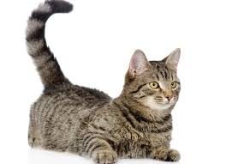

I see. I see.

1 cat I see.

I see. I see.

I see 1 cat.

Form B: two objects



I see 1 cat.

I see 1 dog.

I see 1 cat and 1 dog.

1 cat and 1 dog I see.

Notes:

1. Pictures

Form 1: with one object

1 bear, 1 cat, 1 bird, 1 pig, 1 cow

Case 1: 1 cat



I see. I see.

1 cat I see.

I see. I see.

I see 1 cat.

Case 2: 1 cat and 1 dog



I see 1 cat.

I see 1 dog.

I see 1 cat and 1 dog.

1 cat and 1 dog I see.

Case 3: 1 bear

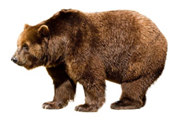

I see. I see.

1 bear I see.

I see. I see.

I see 1 bear.

Case 4: 1 monkey and 1 tiger

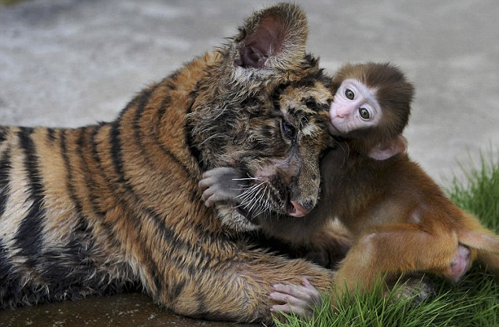

I see 1 tiger.

I see 1 monkey.

I see 1 tiger and 1 monkey.

1 tiger and 1 monkey I see.

Case 5: 1 bird

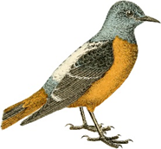

I see. I see.

1 bird I see.

I see. I see.

I see 1 bird.

Case 6: 1 pig and 1 cow

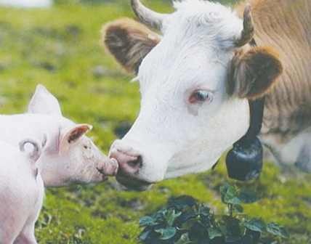

I see 1 cow.

I see 1 pig.

I see 1 cow and 1 pig.

1 cow and 1 pig I see.

Case 7: 1 deer

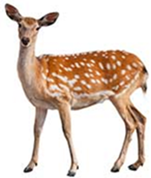

I see. I see.

1 deer I see.

I see. I see.

I see 1 deer.

Case 8: 1 turtle and 1 duck

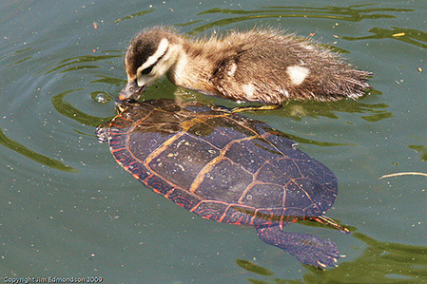

I see 1 turtle.

I see 1 duck.

I see 1 turtle and 1 duck.

1 turtle and 1 dug I see.

Case 9: 1 pig

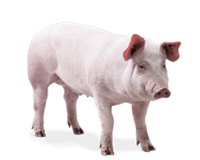

I see. I see.

1 pig I see.

I see. I see.

I see 1 pig.

Case 10: 1 deer and 1 rabbit

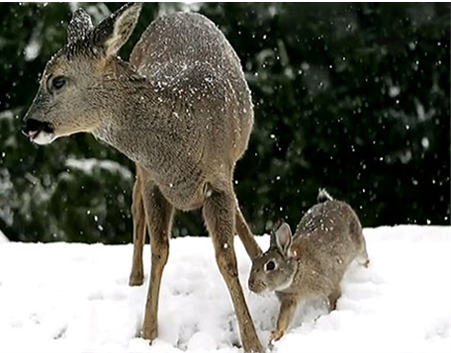

I see 1 deer.

I see 1 rabbit.

I see 1 deer and 1 rabbit.

1 deer and 1 rabbit I see.

Form 1: with 1 object

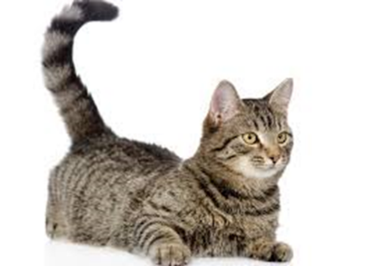 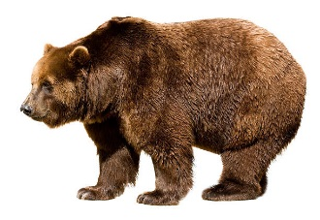 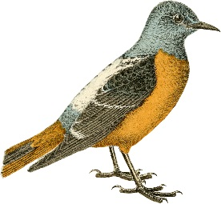

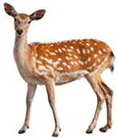 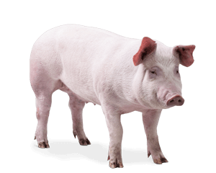

Form 2: with two different objects

1 cat and 1 dog, 1 tiger and 1 monkey, 1 cow and 1 pig, 1 duck and 1 turtle, 1 deer and 1 rabbit





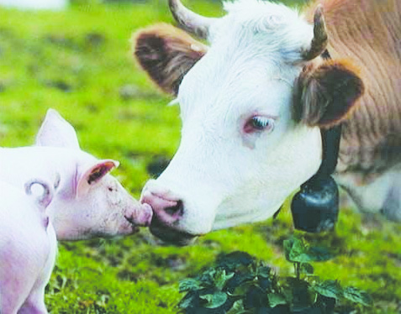

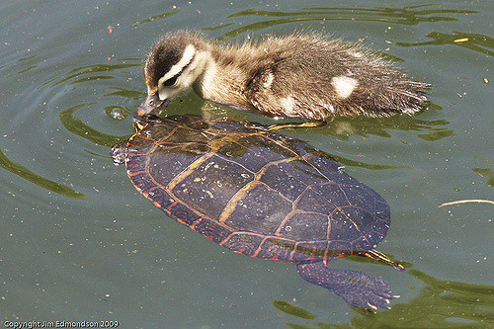

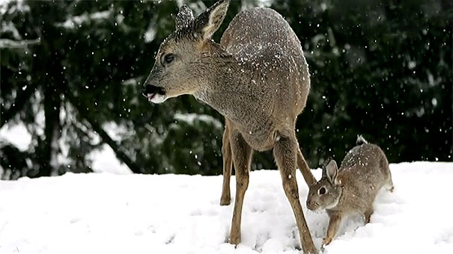

2. New words:

see, bear, cat, bird, pig, cow, tiger, monkey, duck, turtle, deer, rabbit, dog

see: perceive with the eyes



bear: a large, heavy mammal that walks on the soles of its feet, having thick fur and a very short tail



cat: a small, furry animal with four legs and a tail

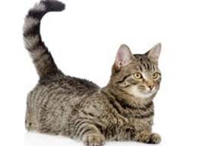

bird: a creature with feathers and wings, usually able to fly



pig: a farm or wild animal with pink, brown, or black skin, short legs and a snout



cow: an adult female of cattle that is kept on a farm to produce milk or meat

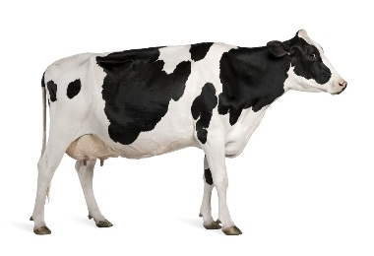

tiger: a large, wild cat that has yellow-orange fur with thick lines of black fur

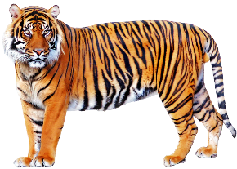

monkey: a small to medium-sized primate that has a long tail, most live in trees in tropical countries

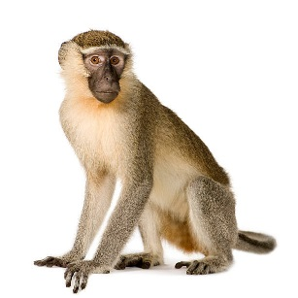

duck: a bird that lives by water and has short legs with webbed feet

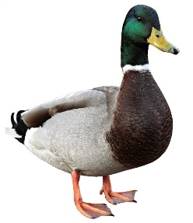

turtle: a reptile that has a shell covering its body

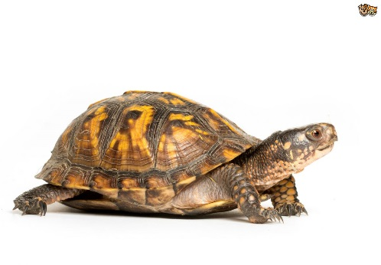

deer: a slender-legged, ruminant mammals having brownish fur

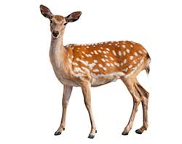

rabbit: a plant-eating mammal, with long ears, long hind legs, and a short tail

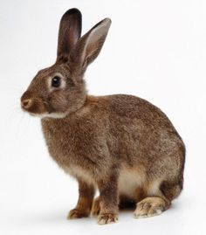

dog: a domesticated carnivorous mammal that typically has a long snout, an acute sense of smell, and a barking, howling, or whining voice

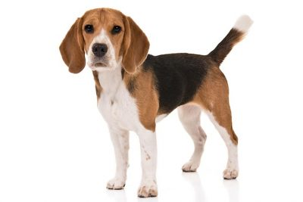

3. New phrases/sentences:

I see.

I see 1 cat.

1 cat I see.

I see 1 cat and 1 dog.

1 cat and 1 dog I see.